**Design Masterclass Module**

Recorded Meeting Minutes on Project Development between

Andreea Mazarianu and Cyclosion Games

**Cyclosion Games Webpage:** <https://www.cyclosion.com/>

**29th January 2020; 8:47 PM – 9: PM (Facebook voice call)**

**Danny Colclough (Cyclosion Games) & Andreea Mazarianu**

Action Points

* The character concept art was postponed until the completion of all the pick-up assets for the game. Therefore, the priority list has become: 1. Pickups 2. Player Character 3. (if time allows it) Enemies and variations
* Fist assets to be conceptualized were established to be the Energy Vials and the Upgrade Kit.
* DC confirmed that there will be more pickups to be conceptualized

**1st February 2020; 8:23 PM – 9:25 PM (Facebook voice call)**

**Danny Colclough (Cyclosion Games) & Andreea Mazarianu**

Meeting aim:

* Feedback on completed work
* Establishing the next deliverables to be conceptualized

The first deliverables were presented (props): Energy Vials and Upgrade Kit.

The client was satisfied with the presented design sheet featuring variations of possible concepts for the Energy Vials and Upgrade Kit assets. From the presented iterations the client has chosen his preferred versions of the 2 props.

The changes requested for the concept designs by the client included:

* Colour change for the Energy Vials to cerulean
* Colour change for the Upgrade Kit to yellow

It has been decided that after the changes were made to the assets, these will be exported as individual PNGs with transparent background and uploaded to the project’s shared Dropbox set by the client.

AM requested to know the priority list for the next two pick-ups that she has to prepare for the following week. DC has stated that he will be creating a spread sheet of all the pick-ups that will need to be conceptualized during the project. The document will be including the pick-up’s name, a brief description of what the purpose/ look of it should be.

**5th February 2020; 12:05 PM – 12:18 PM (Facebook voice call)**

**Danny Colclough (Cyclosion Games) & Andreea Mazarianu**

Meeting aim:

* Presentation of the next deliverables, including details and visual references to be followed

DC provided a link to the Google Spreadsheet with the start of the pick-ups list. The prioritized concepts for the following weeks were established to be for the Charger weapon and Health pickup. (see image provided below) A brief description of the Data Core pickup was mentioned – enhanced floppy disk design - but was not included at the time in the table of contents. Each listed asset needs to be conceptualized before moving to designing the main character of the game.

Next deliverables:

* Charger Weapon
* 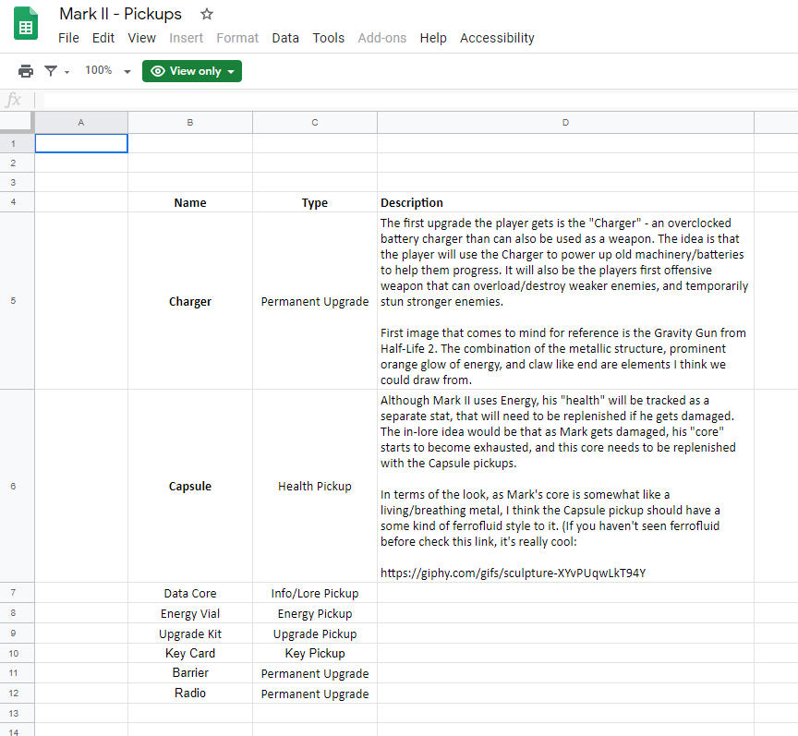Health Capsule

**12th February 2020; 10:29 AM – 10:58 AM (Facebook Messenger)**

**Danny Colclough (Cyclosion Games) & Andreea Mazarianu**

AM has contacted DC in order to inform and apologize for the possibility of completing the work later than agreed because she was preparing for the Final Project Presentation on 17th February.

The client approved of the project being on hold and was happy to be informed about the changes in advance. The newly set deadline was set to be on the 25th February 2020.

AM requested that the communication should be changed to email for future updates. DC agreed.

**25th February 2020 (E-mail)**

**Danny Colclough (Cyclosion Games) & Andreea Mazarianu**

AM has provided a project update to DC via email (see image below – Zoom In). This included:

* Design sheet for the Charger weapon (presenting variations)
* Design sheet for the Health pick-up
* Comment on how the references provided were used
* Suggestions on how the references provided were modified to fit the game’s IP (maintain consistency – Energy Vials must fit the colour of the Charger weapon since both of them are powered by the same element) and convey the desired message to the player (based on shape psychology)
* 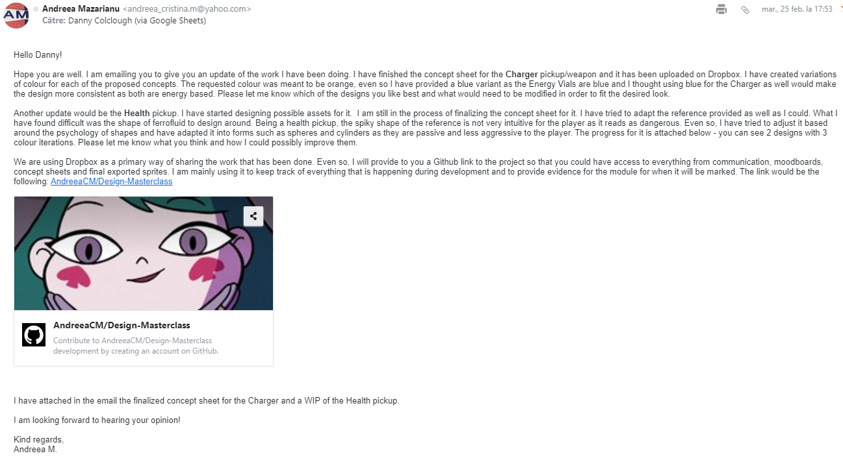Provided extra development tracking details – GitHub. Although the project’s deliverables are uploaded to a shared Dropbox, a link to the project’s Github was provided as backup for the files. Moreover, it includes all meeting minutes, moodboards, design sheets and exported 2D assets that the client may be interested in.

**27th February 2020 (E-mail)**

**Danny Colclough (Cyclosion Games) & Andreea Mazarianu**

Reply from DC (image of the response is provided below – Zoom In) underlined the following aspects:

* Pleased with design sheets
* Agreed on the suggestions made on the design adjustments for the Charger weapon and Health pickup
* Chosen the preferred designs for the 2 assets
* Made comments on how they could be improved to fit the requirements of the game and provided a reference image for better understanding of the use of the Charger weapon
* Changes to the Charger weapon refer to the removal of the grip, as it will be a mount on the main character’s forearm.
* Offered to provide additional information on the assets if needed.
* Stated that the Google Spreadsheet will be completed with additional information for the rest of the assets by 1st March.

[capture of the E-mail attached below]

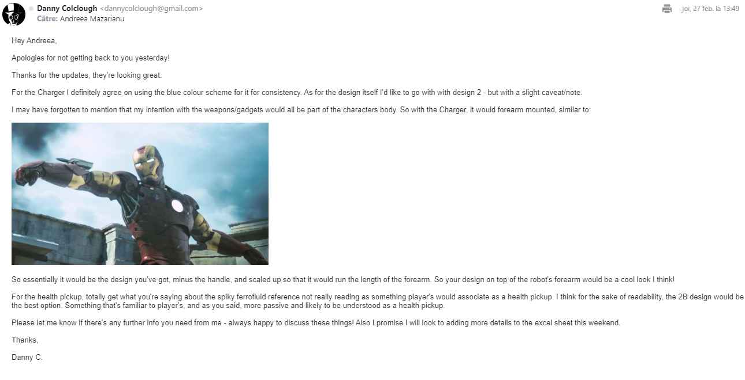

**17th March 2020 (E-mail)**

**Danny Colclough (Cyclosion Games) & Andreea Mazarianu**

Since the Google Spreadsheet has not been completed with additional information by the client, AM decided to present DC the concept art sheet for the Data Core asset (since details and requirements for it have been specified during a voice call on the 5th February 2020).

Updates given to DC include:

* Data Core concept design sheet
* Confirmation of previous chosen assets being exported as PNGs and uploaded on the shared Dropbox
* Mark_2 Game Logo (unsolicited in the brief but completed for the Portfolio module)
* Mark_2 Promotional Thumbnail (unsolicited in the brief but completed for the Portfolio module)

Other concerns expressed in the email:

* Asked for an updated Google Spreadsheet for the asset list that need to be conceptualized
* Reassured the client that once the asset list was completed, the character design for the main character of the game will be following to be completed

[capture of the E-mail attached below]

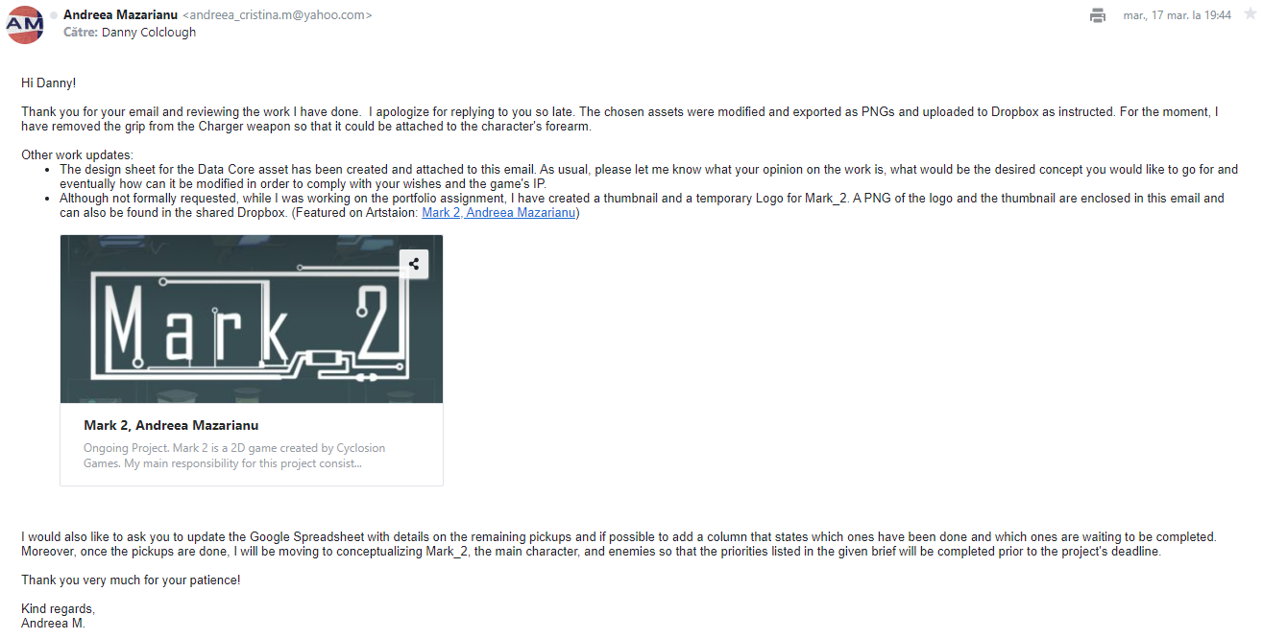

**18th March 2020; 12:37PM – 12:52 PM (Facebook voice call)**

**Danny Colclough (Cyclosion Games) & Andreea Mazarianu**

AM got in touch with DC in order to inform him of the update e-mail sent on 17th March 2020.

DC confirmed that he is knowledgeable of the update. The client apologized on being late with replying to it due to recent changes at the workplace caused by COVID-19.

DC has established the next asset to be conceptualized – Key Card. No special requirements were mentioned, therefore giving creative freedom to AM. The only constraints to be kept are the established style. Design sheet must be provided prior to 23rd March. Moreover, the client has provided the company’s logo to be included in all the design sheets produced during the project.

AM discussed possible ideas with the client regarding the Key Card’s design, including possible materials the concept would be based around – metal and glass.

Tasks to be completed by 23rd March:

* Concept design sheet for Key Card asset
* Include Cyclosion Game company’s logo in all design sheets produced during the projects alongside with the created logo for the game by AM

DC specified that he would review the concept designs created and send a response via email as soon as possible.

**20th March 2020 (E-mail)**

**Danny Colclough (Cyclosion Games) & Andreea Mazarianu**

AM has presented the project progress. This includes:

* Design sheet for the Key Card pickup – including variations of the icons and other possible layouts
* Cyclosion Game’s logo and the created logo for *Mark_2* were included on all of the design sheets made so far
* Additional: reorganization of the shared Dropbox into categories in order to facilitate navigation

Suggestions were made to the client with regard to possible faults in design for one of the variations provided.

[capture of the E-mail attached below]

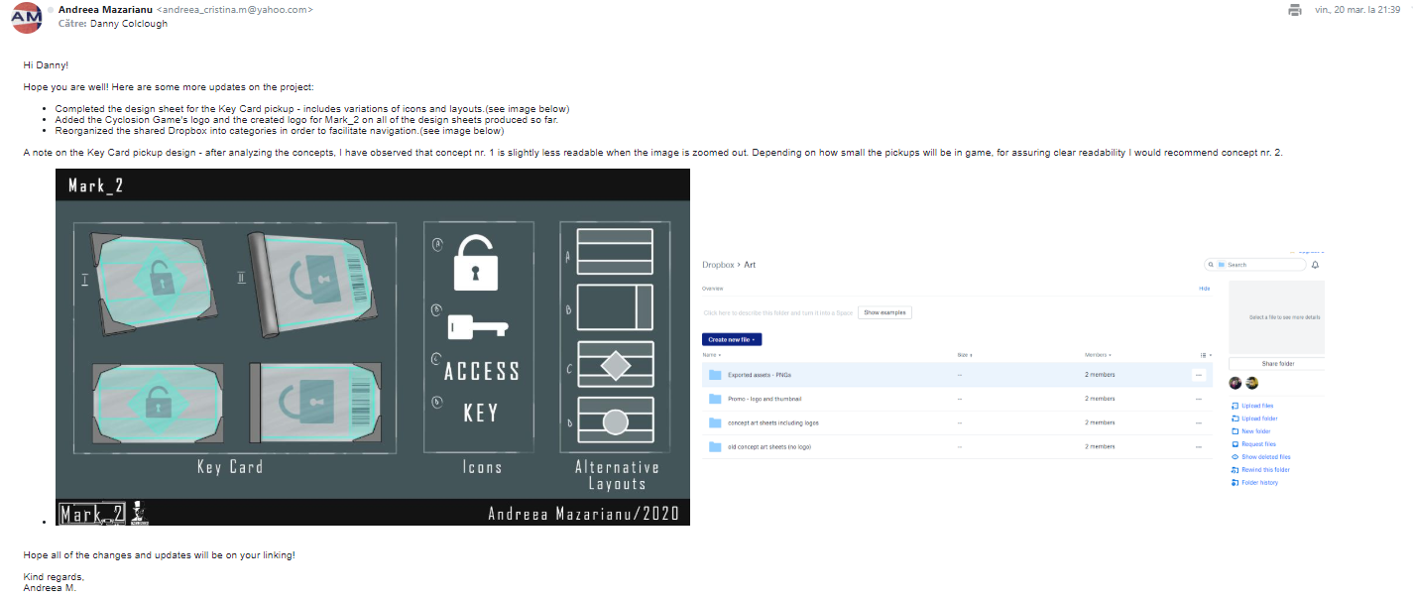

**25th March 2020 (E-mail)**

**Danny Colclough (Cyclosion Games) & Andreea Mazarianu**

DC replied to the previous e-mail. Some of the major pointers to be taken from the reply include:

* Feedback on the Data Core concept – liked the first two designs and the differences between the in-game info and audio files
* Feedback on the Key Card concept – agreed on the suggestions made in the previous email
* Feedback on created logo for the game included on the design sheets – the client liked it
* Update on descriptions on the Pickup Google Spread Sheet
* Preferred designs were picked
* Changes to the Key Card were requested - rotate the lock icon
* Query on what the icons and layouts sections on the design sheet are was expressed
* Client suggested that after completing the list of pickups, he would gather visual references and create descriptions for the player character to be conceptualized base on

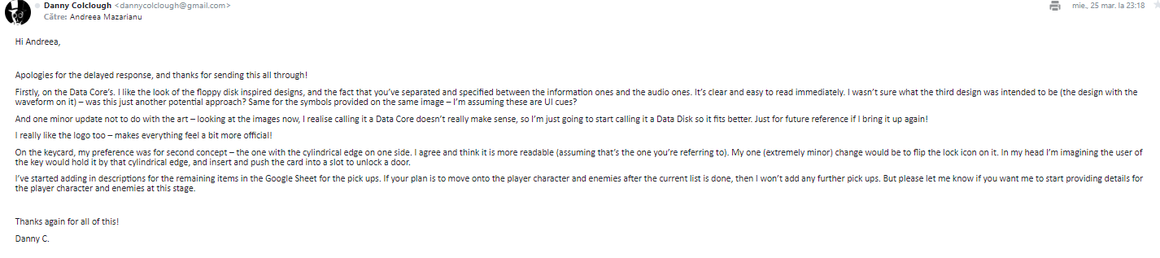[capture of the E-mail attached below]

**26th March 2020 (E-mail)**

**Danny Colclough (Cyclosion Games) & Andreea Mazarianu**

AM replied to DC. Pointers include:

* Answer to the client’s queries on the separated icons and layouts presented on the Key Card’s design sheet
* Answer to the client’s queries on the different approach presented on the Data Core’s design sheet
* Requested that the description for the next two pickups (Barrier and Radio) to be completed on the Google Spread Sheet as there was no description to work from
* Agreed with the client on receiving the necessary descriptions and visual references for the PC to be conceptualized based on

[capture of the E-mail attached below]

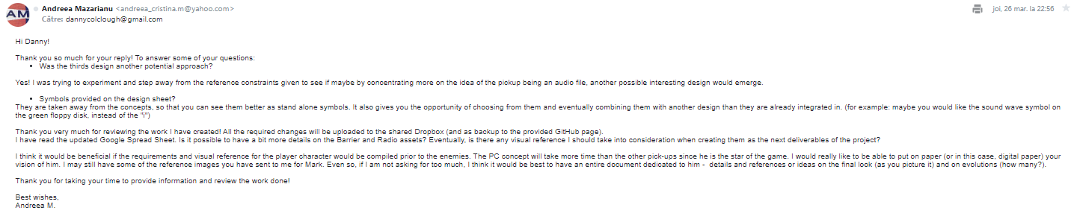

**6th April 2020 (E-mail)**

**Danny Colclough (Cyclosion Games) & Andreea Mazarianu**

DC reply to the previous e-mail included:

* Change to the approach in development for the Barrier and Radio asset
* Request to know opinion on following an already existing design for the PC when conceptualizing it in the pre-established style.

[capture of the E-mail attached below]

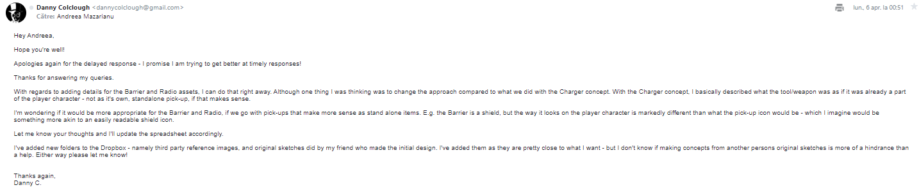

**6th April – 8th April 2020 (E-mails)**

**Danny Colclough (Cyclosion Games) & Andreea Mazarianu**

Communication between DC and AM discusses scheduling a voice call.

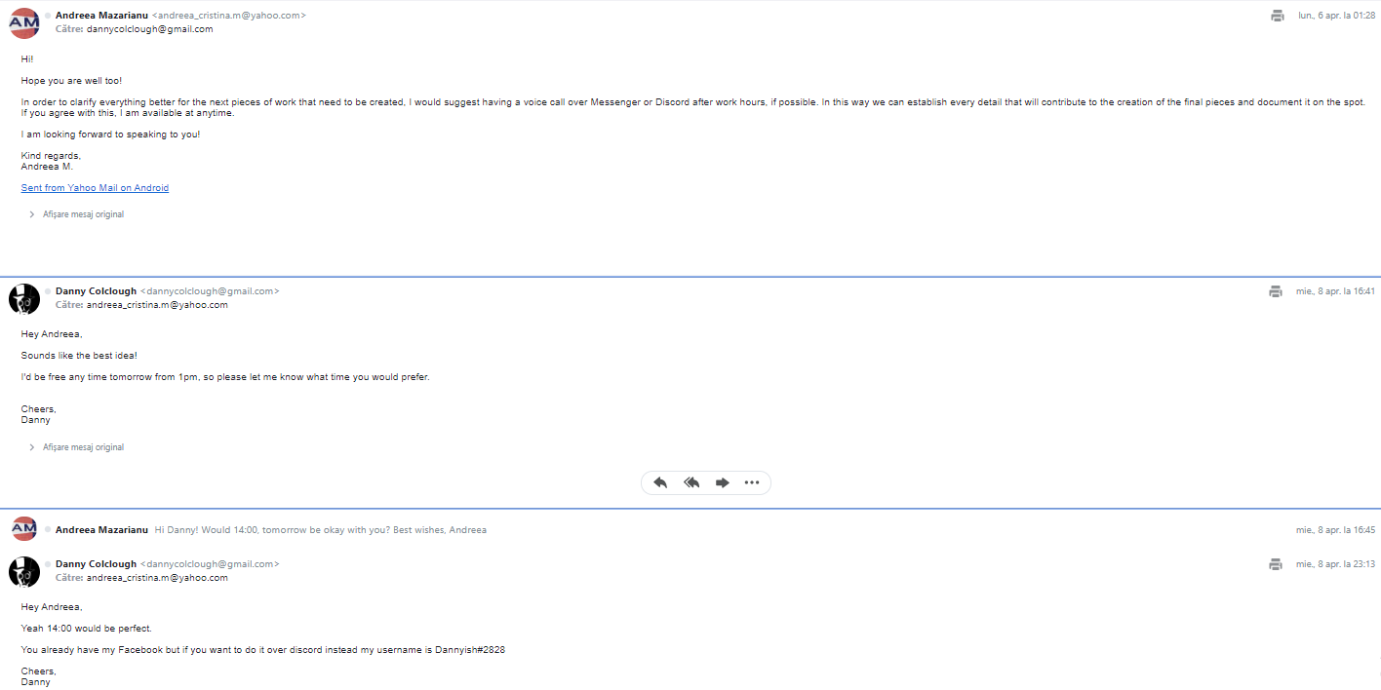

**9th April 2020; 2:00 PM – 3:20 PM (Discord voice call)**

**Danny Colclough (Cyclosion Games) & Andreea Mazarianu**

Meeting aim:

* Discuss client’s requests for creating the PC concept
* Discuss the changed details on Radio and Barrier pickups
* Establish the scope of what is requested in relationship with the remaining time for the assignment to be completed
* Presentation of the iterated Key Card sprite based on feedback
* Additional: presentation of all re-exported PNGs – all sprites presented minor outline mistakes; these were corrected and re-uploaded to the shared Dropbox

Action points:

Regarding the last two pickups – Barrier and Radio:

* Unlike the other pickups, the Barrier sprite, once picked up it will be displayed on the PC as a shield during gameplay. => consider how this would look like both as a pickup and incorporated on the PC.
* Radio pickup – the pickup’s purpose was described. The intended design for it was suggested to be resembling circuits/ system on a chip as it would be one of the PC’s upgrades. This upgrade is not visible on the character. Once obtained, the Radio pickup will generate dialog boxes/interfaces that display additional information on the screen. => conceptualize the Radio pickup and think about possible designs for the dialog boxes.

Regarding the PC:

* Style must remain the same as the pickup. => use same style references given at the beginning of the project in the Brief
* Use a provided older concept for the PC to recreate and improve/ create variations etc.

|  |  |  |
| --- | --- | --- |
|  |  |  |

* Distancing from the given reference is encouraged. Even so, the wanted elements must be kept in mind.
* Client went through all of the provided visual reference pointing out elements that he wishes to be present in the final design of the PC

|  |  |
| --- | --- |
|  | 🡨 things to inspire the design: the cables under the metal armor |
|  | 🡨 body shape and design  🡨 cape |
|  | 🡨 head shape (mostly frond of the head) |
|  | 🡨 distribution of armor  🡨 metal clusters that make up the armor |

Many aspects regarding the PC’s journey through the game were discussed. The PC evolves visibly during the game: from a destroyed robot, Mark 2 becomes a fully built, armored machine.

Start (one arm, no legs) 🡪 Gain all limbs 🡪 Gain armor 🡪 End (fully built up robot, armored and fully polished)

End version should present cape, shields, Charger weapon on forearm, no weak spots, visor, ‘mouth shield’, helmet.

**For the remaining time of the project it was decided that the concept to be created will feature the end version of the PC and variations.**

Other comments:

* Since pickup concept art production comes to an end, the client expressed to be satisfied with all of the designs provided. DC confirmed that the pre-established style was followed and that the created assets are consistent in style.

**Tasks to be completed for the remaining weeks:**

* **Week 6** – Barrier and Radio pickups
* **Week 7** – start concept for PC
* **Week 8** – finish concept for PC

All updates to be sent via e-mail. No formal meeting scheduled for the future due to client’s schedule.